**2023 CS Maths**

Q.1 A series of natural numbers F1, F2, F3, F4, F5, F6, F7, ... obeys Fn+1 = Fn + Fn−1 for all integers n ≥ 2.

If F6 = 37, and F7 = 60, then what is F1?

(A) 4

(B) 5

(C) 8

(D) 9

Q.2 Consider two functions of time (t),

f(t) = 0.01 t^2

g(t) = 4 t

where 0 < t < ∞.

Now consider the following two statements:

(i) For some t > 0, g(t) > f(t).

(ii) There exists a T, such that f(t) > g(t) for all t > T.

Which one of the following options is TRUE?

(A) only (i) is correct

(B) only (ii) is correct

(C) both (i) and (ii) are correct

(D) neither (i) nor (ii) is correct

Q.3 f(x) and g(y) are functions of x and y, respectively, and f(x) = g(y) for all real values of x and y. Which one of the following options is necessarily TRUE for all x and y?

(A) 

(B) 

(C) 

(D) 

Q.4 The Lucas sequence Ln is defined by the recurrence relation:

Ln = Ln−1 + Ln−2, for n ≥ 3,

with L1 = 1 and L2 = 3.

Which one of the options given is TRUE?

(A) 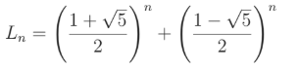

(B) 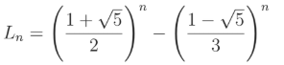

(C) 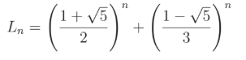

(D) 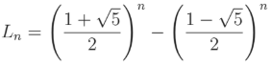

Q.5 Let

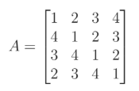

And

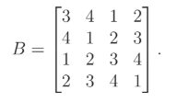

Let det(A) and det(B) denote the determinants of the matrices A and B,

respectively.

Which one of the options given below is TRUE?

(A) det(A) = det(B)

(B) det(B) = −det(A)

(C) det(A)=0

(D) det(AB) = det(A) + det(B)

Q.6 Geetha has a conjecture about integers, which is of the form

∀x (P(x) =⇒ ∃yQ(x, y)),

where P is a statement about integers, and Q is a statement about pairs of integers. Which of the following (one or more) option(s) would imply Geetha’s conjecture?

(A) 

(B) 

(C) 

(D) 

Q.7 Let f(x) = x3 + 15x2 − 33x – 36 be a real-valued function. Which of the following statements is/are TRUE?

(A) f(x) does not have a local maximum.

(B) f(x) has a local maximum.

(C) f(x) does not have a local minimum.

(D) f(x) has a local minimum.

Q.8 Let f and g be functions of natural numbers given by f(n) = n and g(n) = n^2. Which of the following statements is/are TRUE?

(A) f ∈ O(g)

(B) f ∈ Ω(g)

(C) f ∈ o(g)

(D) f ∈ Θ(g)

Q.9 Let A be the adjacency matrix of the graph with vertices {1, 2, 3, 4, 5}.

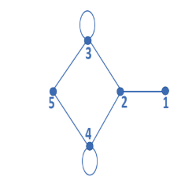

Let λ1, λ2, λ3, λ4, and λ5 be the five eigenvalues of A. Note that these eigenvalues need not be distinct.

The value of λ1 + λ2 + λ3 + λ4 + λ5 = _____________.

Q.10 The value of the definite integral 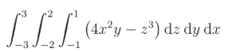is (Rounded off to the nearest integer)

Q.11 Let U = {1, 2,...,n}, where n is a large positive integer greater than 1000. Let k be a positive integer less than n. Let A, B be subsets of U with |A| = |B| = k and A ∩ B = ∅. We say that a permutation of U separates A from B if one of the following is true.

- All members of A appear in the permutation before any of the members of B.

- All members of B appear in the permutation before any of the members of A.

How many permutations of U separate A from B?

(A) n!

(B) 

(C) 

(D) 

Q.12 Let f: A → B be an onto (or surjective) function, where A and B are non-empty sets. Define an equivalence relation ∼ on the set A as a1 ∼ a2 if f(a1) = f(a2), where a1, a2 ∈ A. Let E = {[x]: x ∈ A} be the set of all the equivalence classes under ∼. Define a new mapping F: E → B as F([x]) = f(x), for all the equivalence classes [x] in E.

Which of the following statements is/are TRUE?

(A) F is NOT well-defined.

(B) F is an onto (or surjective) function.

(C) F is a one-to-one (or injective) function.

(D) F is a bijective function.

Q.13 Let X be a set and 2X denote the powerset of X.

Define a binary operation Δ on 2X as follows:

AΔB = (A − B) ∪ (B − A).

Let H = (2X, Δ). Which of the following statements about H is/are correct?

(A) H is a group.

(B) Every element in H has an inverse, but H is NOT a group.

(C) For every A ∈ 2X, the inverse of A is the complement of A.

(D) For every A ∈ 2X, the inverse of A is A.

Q.14 Consider a random experiment where two fair coins are tossed. Let A be the event that denotes HEAD on both the throws, B be the event that denotes HEAD on the first throw, and C be the event that denotes HEAD on the second throw.

Which of the following statements is/are TRUE?

(A) A and B are independent.

(B) A and C are independent.

(C) B and C are independent.

(D) Prob(B|C) = Prob(B)

Q.15 Let G be a simple, finite, undirected graph with vertex set {v1,...,vn}. Let Δ(G) denote the maximum degree of G and let N = {1, 2,...} denote the set of all possible colors. Color the vertices of G using the following greedy strategy: for i = 1,...,n

color(vi) ← min{j ∈ N : no neighbour of vi is colored j}

Which of the following statements is/are TRUE?

(A) This procedure results in a proper vertex coloring of G.

(B) The number of colors used is at most Δ(G) + 1.

(C) The number of colors used is at most Δ(G).

(D) The number of colors used is equal to the chromatic number of G.

Q.16 Let U = {1, 2, 3}. Let 2U denote the powerset of U. Consider an undirected graph G whose vertex set is 2U . For any A, B ∈ 2U , (A, B) is an edge in G if and only if (i) A = B, and (ii) either A B or B A. For any vertex A in G, the set of all possible orderings in which the vertices of G can be visited in a Breadth First Search (BFS) starting from A is denoted by B(A). If ∅ denotes the empty set, then the cardinality of B(∅) is .